Name:  Class: | ____________________________________  ________________ |  | Date:_________
 | Year 10 Pythagoras and Trigonometry Investigation  SCORE:  /24  Design A Bridge
Total Time: | 2 lessons in class 1 week at home
Weighting: | 12.5%
Equipment: | To be provided by the student: Pen, pencil, ruler, scientific calculator, Interactive notebook

The Sheik Zayed Bridge in Abu Dhabi was built in 2010 and can carry 16,000 cars per hour.

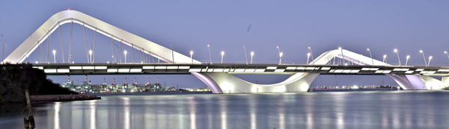

This bridge is 842m long in total (it extends further than this photo) and cost $200,000,000 to build. On the above picture the highest support is 68m above the road.

The Matagarup Bridge in Perth cost $91,000,000 to build and spans 400m. The height on the below picture is 71m.
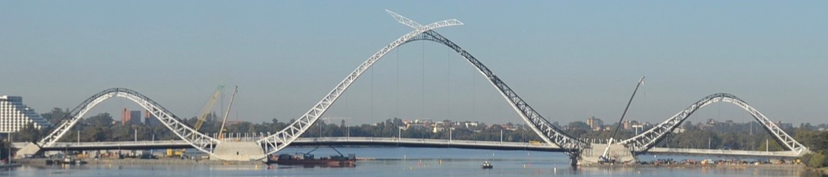

Your task is to design a new bridge to span 180m across the lake in Rivergums Reserve in Baldivis. You will break up your bridge into a series of right-angle triangles to work out the lengths of each side out the lengths of main structure, as well as the total length of all support cables. You will need to estimate the total cost of the bridge based on the costs for the Matagarup and Sheik Zayed bridges.

